USER GUIDE
Geo Speak

- About Geo Speak:

The goal of this project is to develop an intelligent translation application that leverages advanced Generative AI technologies, including Large Language Models (LLMs) and Embedding APIs, to provide accurate and contextually relevant translations. The application will be designed to handle user input text and translate it between various languages with enhanced semantic understanding.
Features and Functionalities:
- Text Input:
  - Description: The application will feature an input field where users can enter text in a source language. A drop-down menu will allow users to select their desired target language from a list of available options.
  - Purpose: To enable users to specify both the text they wish to translate and the language into which they want it translated.
- Text Processing:
  - Description: Upon receiving the input text, the application will use an Embedding API to convert the text into a high-dimensional semantic vector. This vector represents the meaning of the text in a way that can be used for further processing.
  - Purpose: To generate a semantic representation of the input text that facilitates accurate retrieval and context-aware translation.
- Document Retrieval:
  - Description: The application will query a Vector Database to find and retrieve documents that are relevant to the generated embedding vector. This helps in understanding the context and nuances of the input text.
  - Purpose: To gather contextually relevant information that will aid in generating a more precise translation.
- Context-aware Prompt Creation:
  - Description: Using the retrieved documents, the application will create a context-aware prompt for the translation model. This prompt will incorporate the context and specifics of the input text to guide the translation process.
  - Purpose: To ensure that the translation takes into account the context of the text, resulting in more accurate and meaningful translations.
- Translation Generation:
  - Description: The application will utilize a Language Model to generate the translation of the input text based on the context-aware prompt. The model will produce the translated text in the target language.
  - Purpose: To provide a coherent and contextually appropriate translation of the original text.
- Result Display:
  - Description: The translated text will be presented to the user in a clear and user-friendly format. The design will ensure that the translated output is easily readable and accessible.
  - Purpose: To deliver the translation results in an intuitive manner, enhancing the user experience.
- Error Handling:
  - Description: The application will include robust error handling mechanisms to address issues that may arise during text processing, document retrieval, or translation generation. Users will receive informative error messages if something goes wrong.
  - Purpose: To ensure that the application operates smoothly and that users are informed of any issues that may affect the translation process.
- User Interface:
  - Description: The application will feature an intuitive and responsive user interface that allows users to input text, select languages, and view translation results effortlessly. The interface will be designed for ease of use and efficiency.
  - Purpose: To provide a seamless and user-friendly experience, making it easy for users to interact with the application and obtain translations.
Conclusion:
This intelligent translation application will combine advanced AI technologies to offer precise, context-aware translations across multiple languages. With its user-centric design and robust functionality, the application aims to meet the needs of users seeking reliable translation services.

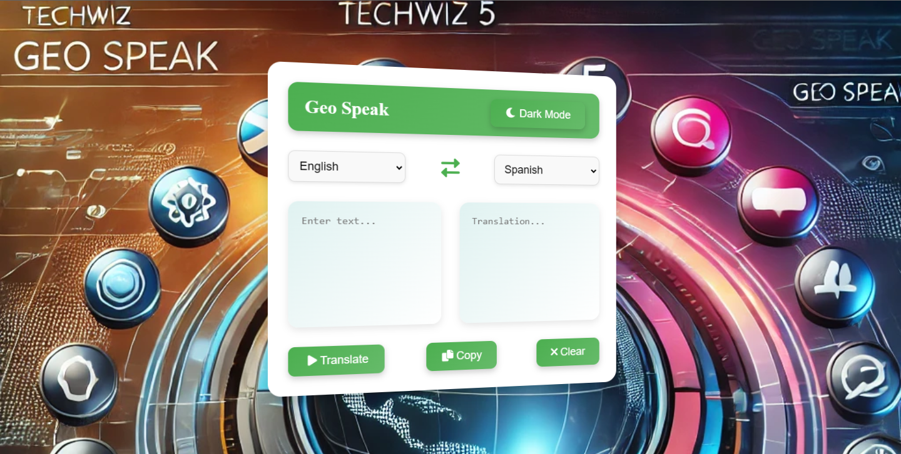
Description: The image shows the interface of a language translation application called Geo Speak. The UI has an option to toggle Dark Mode and allows users to translate text between different languages. The interface includes drop-down menus for selecting the input and output languages, a text area to enter the text, and buttons to Translate, Copy, or Clear the translated output. The background features a futuristic design with various icons and a digital globe, reinforcing the global nature of the translation service.

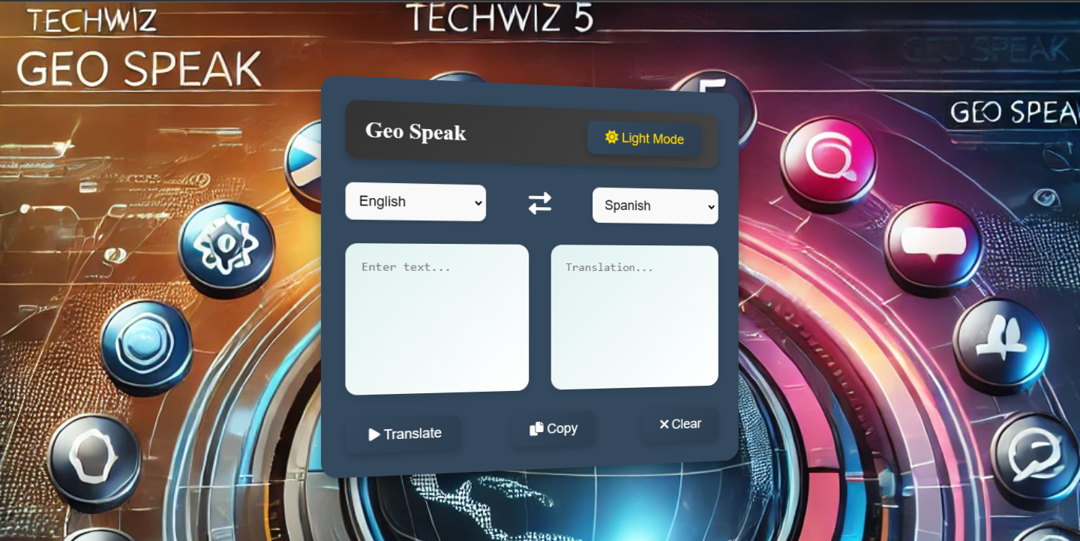
Description: The image shows the interface of a language translation application called Geo Speak. The UI has an option to toggle Light Mode and allows users to translate text between different languages. The interface includes drop-down menus for selecting the input and output languages, a text area to enter the text, and buttons to Translate, Copy, or Clear the translated output. The background features a futuristic design with various icons and a digital globe, reinforcing the global nature of the translation service.

